Sample Newsletter Article: The System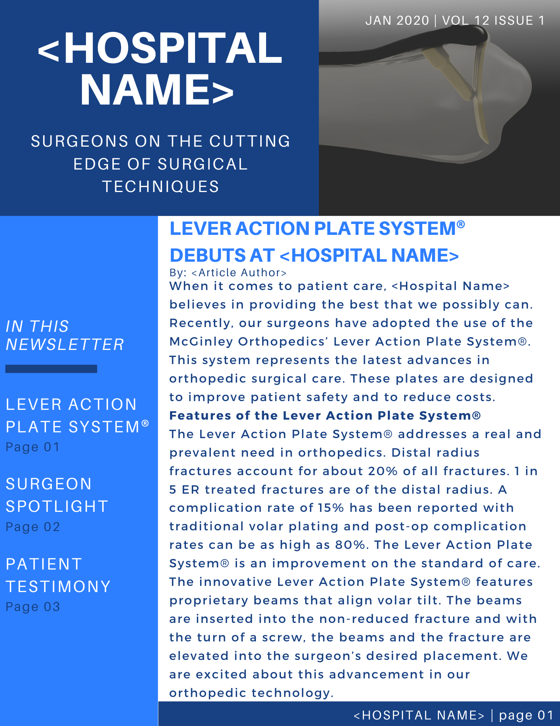
Below is the text of the article from the sample picture on the previous page in an easily editable format. Feel free to use any or all of it in your newsletter. Pictures are available in the picture and logo section of the press kit.
<Hospital Name> Surgeons on the Cutting Edge of Surgical Techniques
Lever Action Plate System® Debuts at <Hospital Name> by <Article Author>
When it comes to patient care, <Hospital Name> believes in providing the best that we possibly can. Recently, our surgeons have adopted the use of the McGinley Orthopedics’ Lever Action Plate System®.
This system represents the latest advances in orthopedic surgical care. These plates are designed to improve patient safety and to reduce costs.
Features of the Lever Action Plate System®
The Lever Action Plate System® addresses a real and prevalent need in orthopedics. Distal radius fractures account for about 20% of all fractures. 1 in 5 ER treated fractures are of the distal radius. A complication rate of 15% has been reported with traditional volar plating and post-op complication rates can be as high as 80%. The Lever Action Plate System® is an improvement on the standard of care.
The innovative Lever Action Plate System® features proprietary beams that align volar tilt. The beams are inserted into the non-reduced fracture and with the turn of a screw, the beams and the fracture are elevated into the surgeon’s desired placement. We are excited about this advancement in our orthopedic technology.

Sample Internal Newsletter: The Surgeon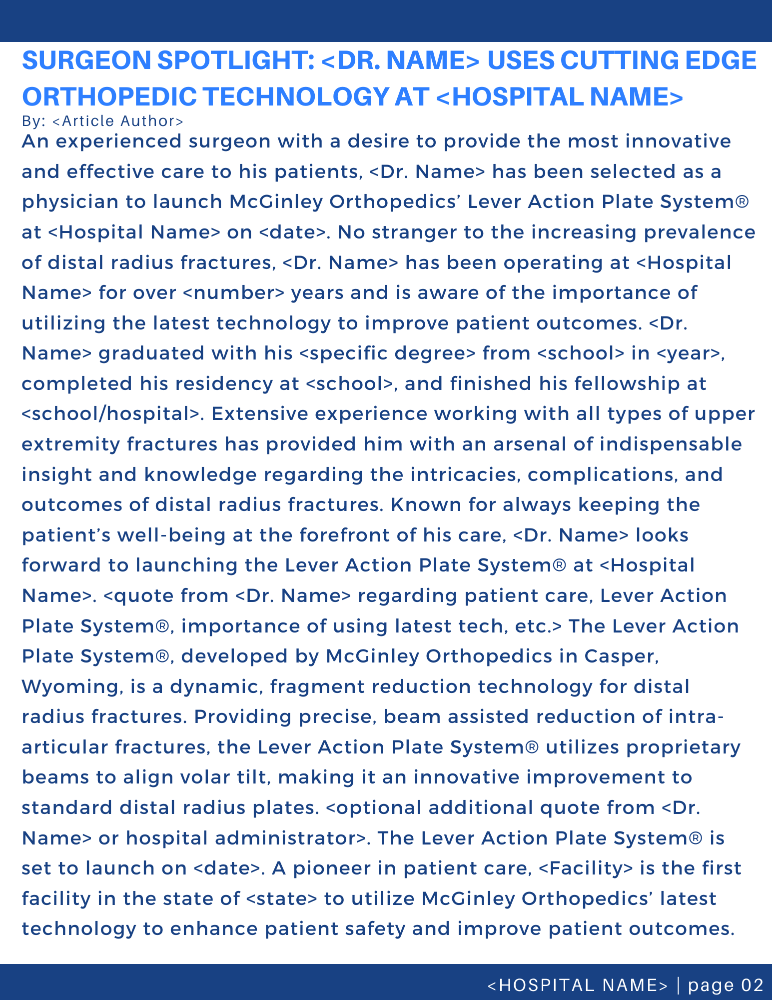
Below is the text of the article from the sample picture on the previous page in an easily editable format. Feel free to use any or all of it in your newsletter. Pictures are available in the picture and logo section of the press kit.
SURGEON SPOTLIGHT: <DR. NAME> USES CUTTING EDGE ORTHOPEDIC TECHNOLOGY AT <HOSPITAL NAME> by <Article Author>
An experienced surgeon with a desire to provide the most innovative and effective care to his patients, <Dr. Name> has been selected as a physician to launch McGinley Orthopedics’ Lever Action Plate System® at <Hospital Name> on <date>. No stranger to the increasing prevalence of distal radius fractures, <Dr. Name> has been operating at <Hospital Name> for over <number> years and is aware of the importance of utilizing the latest technology to improve patient outcomes. <Dr. Name> graduated with his <specific degree> from <school> in <year>, completed his residency at <school>, and finished his fellowship at <school/hospital>. Extensive experience working with all types of upper extremity fractures has provided him with an arsenal of indispensable insight and knowledge regarding the intricacies, complications, and outcomes of distal radius fractures. Known for always keeping the patient’s well-being at the forefront of his care, <Dr. Name> looks forward to launching the Lever Action Plate System® at <Hospital Name>. <quote from <Dr. Name> regarding patient care, Lever Action Plate System®, importance of using latest tech, etc.> The Lever Action Plate System®, developed by McGinley Orthopedics in Casper, Wyoming, is a dynamic, fragment reduction technology for distal radius fractures. Providing precise, beam assisted reduction of intra-articular fractures, the Lever Action Plate System® utilizes proprietary beams to align volar tilt, making it an innovative improvement to standard distal radius plates. <optional additional quote from <Dr. Name> or hospital administrator>. The Lever Action Plate System® is set to launch on <date>. A pioneer in patient care, <Facility> is the first facility in the state of <state> to utilize McGinley Orthopedics’ latest technology to enhance patient safety and improve patient outcomes.

Sample Internal Newsletter: The Patient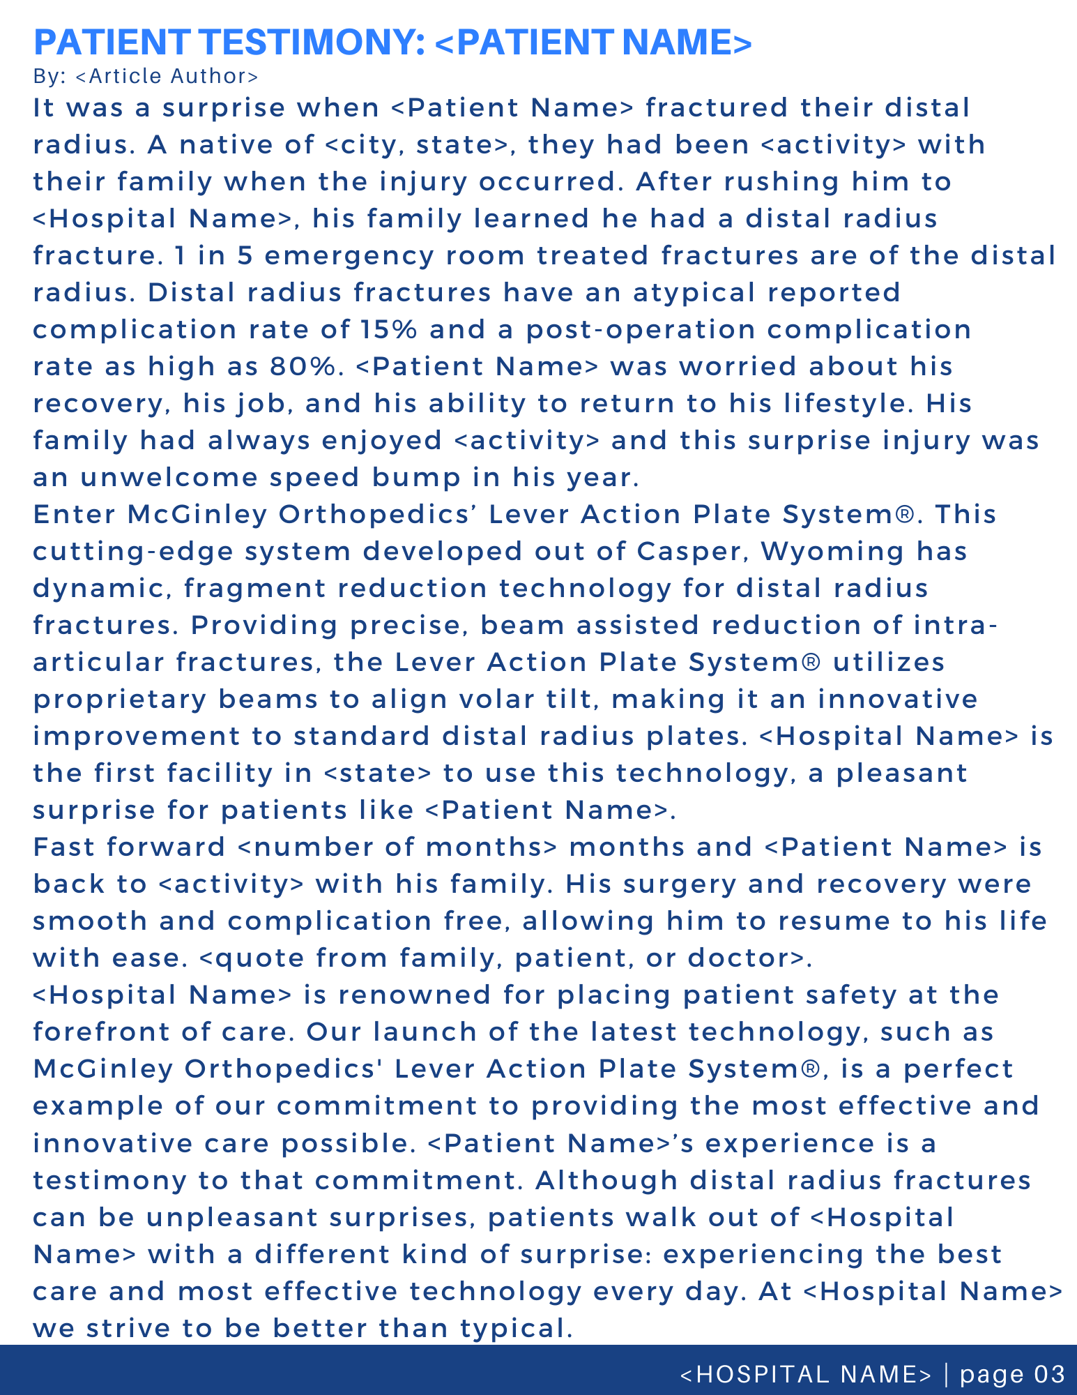
Below is the text of the article from the sample picture on the previous page in an easily editable format. Feel free to use any or all of it in your newsletter. Pictures are available in the picture and logo section of the press kit.
PATIENT TESTIMONY: <PATIENT NAME> by <Article Author>
It was a surprise when <Patient Name> fractured their distal radius. A native of <city, state>, they had been <activity> with their family when the injury occurred. After rushing him to <Hospital Name>, his family learned he had a distal radius fracture. 1 in 5 emergency room treated fractures are of the distal radius. Distal radius fractures have an atypical reported complication rate of 15% and a post-operation complication rate as high as 80%. <Patient Name> was worried about his recovery, his job, and his ability to return to his lifestyle. His family had always enjoyed <activity> and this surprise injury was an unwelcome speed bump in his year.
Enter McGinley Orthopedics’ Lever Action Plate System®. This cutting-edge system developed out of Casper, Wyoming has dynamic, fragment reduction technology for distal radius fractures. Providing precise, beam assisted reduction of intra-articular fractures, the Lever Action Plate System® utilizes proprietary beams to align volar tilt, making it an innovative improvement to standard distal radius plates. <Hospital Name> is the first facility in <state> to use this technology, a pleasant surprise for patients like <Patient Name>.
Fast forward <number of months> months and <Patient Name> is back to <activity> with his family. His surgery and recovery were smooth and complication free, allowing him to resume to his life with ease. <quote from family, patient, or doctor>.
<Hospital Name> is renowned for placing patient safety at the forefront of care. Our launch of the latest technology, such as McGinley Orthopedics' Lever Action Plate System®, is a perfect example of our commitment to providing the most effective and innovative care possible. <Patient Name>’s experience is a testimony to that commitment. Although distal radius fractures can be unpleasant surprises, patients walk out of <Hospital Name> with a different kind of surprise: experiencing the best care and most effective technology every day. At <Hospital Name> we strive to be better than typical.

